Northern Queensland Primary Health Network

Telehealth Toolkit
Residential Aged Care Homes
Updated December 2025

Acknowledgement
This toolkit has been developed by Northern Queensland Primary Health Network (NQPHN) from materials shared by Country to Coast Queensland, as part of Telehealth Grants for Residential Aged Care Facilities program, funded by the Department of Health and Aged Care.


Contact us
Cairns  p: (07) 4034 0300  Level 5, 111 Grafton Street  Cairns, Qld 4870 | Townsville  p: (07) 4796 0400  Building 500, Level 3  1 James Cook Drive, Douglas, Qld 4814 | Mackay  p: (07) 4963 4400  2/45 Victoria Street (Ground Floor)  Mackay, Qld 4740
e: ophapc@nqphn.com.au w: www.nqphn.com.au
Contents
Introduction 4
Guide to creating telehealth policy and procedures 5
Policy – Telehealth Consultation 6
Telehealth Example Procedure – Quality and Standards 7
Telehealth Example Procedure ‒ Selection and Appropriateness 8
Telehealth Example Procedure ‒ Consent 10
Telehealth Example Procedure ‒ Scheduling 11
Telehealth Example Procedure ‒ Technology 12
Telehealth Example Procedure ‒ Physical Set-up 14
Telehealth Example Procedure ‒ Communications and Privacy 16
Telehealth Example Procedure ‒ Conducting a consultation 18
Telehealth promotion flyer 20
Telehealth pamphlet 22
NQPHN Telehealth Cart flyer for healthcare providers 24
Telehealth Consultation Checklist 26
Telehealth Consult Flowchart 29
Consultation in progress sign 32
Telehealth Technology Support template 34
Troubleshooting Guide 37
Telehealth platforms and software user guides 39
Telehealth software comparison 41
Consent guide and template 43
Complementary services template 45
Feedback question examples and reporting templates – residents and staff 47
Feedback questionnaires and reporting 48
Resident feedback question examples 49
Resident scoring template example 50
Staff feedback question examples 51
Staff scoring template example 52
Register of telehealth consultations 53
Telehealth consultations log example 54

Introduction
Northern Queensland Primary Health Network (NQPHN) has developed this resource toolkit in partnership with Country to Coast Queensland to complement telehealth equipment introduced to Residential Aged Care Homes (RACHs) across northern Queensland to assist with telehealth consultations for their residents. The promotion and sponsorship of these telehealth services are initiatives of the Department of Health and Aged Care.
Telehealth consultations provide aged and vulnerable residents of RACHs with timely, convenient, and equitable access to general practitioners (GPs) and other health professionals, eliminating the need to travel or wait for an in-person visit or appointment.
This toolkit’s resources are intentionally broad so that RACHs can adapt them to their specific needs during the initial implementation and long-term maintenance of telehealth services. Many templates include sufficient detail for customisation, while others remain less defined.
The toolkit serves as a practical resource for RACH staff to refer to and utilise, enhancing their understanding of telehealth services. NQPHN has complemented the resources by providing linkages to education provided by appropriate telehealth software vendors.
Each resource within the toolkit features a cover page that includes its name, a description, and purpose. Lists of sources and links to further information are also provided. In the first resource, these lists are given with each procedure; for others, they are on the cover page. This additional information is recommended for facilities to access when adapting and developing their own resources.

Using this Toolkit
The NQPHN Telehealth Toolkit for Residential Aged Care Homes has been developed in a Word document to allow you to customise and update templates and resources to best suit your facility and resident’s needs. Whilst most of the resources are created within this Word document, others are available online to be downloaded. You will find URL weblinks on the cover page for each tool where a print-ready file is available online for download.




The content and templates provided in this toolkit are for guidance purposes only. The intention of the resources is for facilities to use of those that apply, when introducing and commencing telehealth services. Facilities are to consider, tailor, and develop their unique range of materials based on their needs. The resources in the toolkit are not a substitute for professional care or legal advice.

Guide to creating telehealth policy and procedures
Resource number | 1.0
Resource name | Guide to creating telehealth policy and procedures
Description | This template is a foundational resource targeted at supporting the RACH towards developing and implementing organisational processes, policies, and procedures that guide the effective use of telehealth.  Telehealth consultations are a service using an interactive audio and video telecommunications system that permits real-time communication between a clinician at another site and a resident of the RACH.  The example policy and procedures within this template are for Residential Aged Care Homes (RACHs) to use the as a starting place, to discuss, explore and customise for their individual situations and set-ups.
Purpose | Incorporating telehealth into everyday work is a notable change from traditional practice. It impacts staff scheduling, Information Technology systems, workflows, and relationships with external clinicians, as well as necessitating additional staff training.  This is a template for creating a telehealth policy and procedures resource for Residential Aged Care Homes.  The process of developing and defining procedures by the organisation should be undertaken whilst introducing and implementing and working towards telehealth consultations becoming normal practice.
Resource guides | A listed selection of numbered and cross-referenced guidelines and toolkit resources aimed at supporting the development of individual procedures, provide supplementary information as appropriate. Source documents and additional online resources are presented in alphabetical order.
Date stamp | 31 March 2025


Policy – Telehealth Consultation


The policy at [insert RACH Residential Aged Care Home] is to provide telehealth consultations as an option for health care service delivery to enhance access in ways that are convenient, safe, and equitable for our residents.
Clinical personnel will offer residents in need of care by an external health care professional a telehealth consultation that meets the standards outlined in the following procedures.

Procedure  reference no. | Example procedure | Procedure description
TH01 | Quality and Standards – Telehealth Equipment and Privacy | Manage consultation in accordance with best practice clinical standards and models of care.
TH02 | Resident Selection and Clinical Appropriateness – Telehealth Consult | Facilitate screening of resident against an agreed set of governance criteria to confirm safety and appropriateness for telehealth.
TH03 | Informed Consent – Telehealth Consult | Ensure the resident (and family) understand what telehealth is, are given the opportunity to ask questions, and agree to proceed.
TH04 | Scheduling a Telehealth Consultation | Consultation is scheduled in collaboration with the external provider and is communicated to others as required.
TH05 | IT Support – Connection, Equipment, and Troubleshooting | Facilitates regular maintenance of equipment and system updates, and a troubleshooting guide for staff.
TH06 | Telehealth Physical Surroundings  and Room Setup | To replicate as closely as possible to an in-person consultation, relating to safe health care, privacy, and efficiency.
TH07 | Telehealth Communications  and Privacy | Ensure that required resident information shared between providers enables safe appropriate clinical assessment and care, in accordance with relevant privacy standards.
TH08 | Conducting a Telehealth Consultation | Facilitate a telehealth session, which is timely, convenient, and safe whilst maintaining the same practice standards for a consultation delivered in person.

Telehealth Example Procedure – Quality and Standards
Procedure Ref. Number | TH01
Example Procedure name | Quality and Standards – Telehealth Equipment and Privacy
Reason for this procedure | To describe the standards for implementing telehealth models of care whilst ensuring effective and safe delivery of health care to residents.
Example procedure |  | Refer to
- The audio and video telecommunications systems used by this facility meet Australian regulations and standards.
- Equipment, software, and communications networks are installed according to approved guidelines.
- The software used by the facility is designed specifically and has functionality for telehealth video consultations.
- The facility has consulted appropriately with other participating health care organisations to ensure they meet Australian standards.
- The software is confirmed as compatible with the systems used by participating healthcare professionals in the area.
- The systems and processes in use by the facility satisfy Australian privacy and security legislation and comply with standards as they continue to evolve. |  | Procedure Guideline TH01A
Procedure guideline TH01A
The following resources may support the development of best practice standards specific to the facility:
- Australian Commission on Safety and Quality in Healthcare, the National Safety and Quality Health Service Standards (NSQHS)
- Australian Medical Association 10 Minimum Standards for Telemedicine
- Digital Health, Information for healthcare providers
- End of Life Directions for Aged Care (ELDAC) Becoming digitally ready a manual for aged care services
- Health Consumers Queensland, Queensland Digital Health Consumer Charter
- Health Direct, Introducing video telehealth to your aged care service
- International Organisation for Standardization (ISO), 2021, ISO 13131:2021 Health Informatics – Telehealth Services – Quality Planning Guidelines
- The Medical Board of Australia Guidelines for technology-based consultations
- The Royal Australasian College of Physicians Telehealth Guidelines and Practical Tips
- Queensland Health, Office of the Chief Allied Health Officer, Telehealth Resources for Allied Health
Effective date: | [Insert start date]
Replaces procedure dated:
Approved by:
Page: | 1 of 1

Telehealth Example Procedure ‒ Selection and Appropriateness
Procedure Ref. Number | TH02
Example Procedure name | Resident Selection and Clinical Appropriateness – Telehealth Consult
Reason for this procedure | Clinical appropriateness assists health care providers to make the most appropriate care and treatment decision for a person with a specific clinical condition (Allied Health Professions Australia (AHPA), 2020). The AHPA guide suggests clinical, quality, safety, and practical factors are considered when assessing suitability for telehealth.
Example procedure |  |  | Refer to
- Clinical judgement by clinical staff at the facility in collaboration with the health professional, with clinical governance responsibility where relevant, will determine the resident’s appropriateness for a telehealth consultation. |  |  | Procedure Guideline  TH02E
- The Criteria for telehealth and clinical prioritisation, current version will be used by clinical staff at the facility when determining selection and appropriateness for telehealth consultation.  The ‘criteria for telehealth and clinical prioritisation’ document is supplementary to this procedure. It should be developed by the facility, requiring regular review. |  |  | Annexure TH02A  Procedure Guideline  TH02
- A range of clinical and non-clinical factors will be considered by staff, including adapting to the unique needs of the resident, when determining suitability of a resident for telehealth.  This ‘range of clinical and non-clinical factors’ is an additional supplementary document (or sub-division) to this procedure, to be developed by the facility. |  |  | Annexure TH02A  Procedure Guideline TH02
- In a crisis situation or if the resident needs emergency services, the same emergency procedure should be followed as was in place prior to the launch of telehealth services.
- If a resident has a standard outpatient appointment with a known Specialist, and that service offers telehealth consultations, residents may utilise the telehealth service
Annexure TH02A | [Insert copy of Criteria for telehealth and clinical prioritisation to be developed by the facility here]. See Procedure Guideline TH02C.
Annexure TH02B | [Insert copy of Range of Clinical and Non-Clinical Factors for Consideration to be developed by the facility here]. See Procedure Guideline TH02D.
Procedure Guideline TH02C | Depending on the resident’s situation, some example health conditions that the facility may decide as criteria and prioritisation for telehealth consultation, may include:  - Residents needing urgent pain relief, wounds review or falls management.  - Residents with immunocompromised conditions or weakened immune system.  - Residents with a debilitating illness where travel is not advised, such as frailty.  - Residents receiving palliative or end of life care.  - Residents requiring monitoring or care planning for their mental health or chronic disease.
Page |  | 1 of 2
Procedure Ref Number TH02 (continued)
Procedure Guideline TH02D | Depending on the resident’s situation some examples of clinical and non-clinical factors the facility may decide as suitable for telehealth consultation, may include:  - The level of physical assessment required.  - If the resident’s clinical needs can be met through a telehealth consultation.  - The resident’s willingness and ability to participate, including any physical, mental, cultural, social, and cognitive barriers.  - Availability of personnel and other support to conduct the consult.  - Availability and access to technology, including internet connection, devices, software.  - An appropriate physical environment is available.
Procedure Guideline TH02E | The following resources may support the development of a resident selection and clinical appropriateness procedure, specific to the facility:  - Allied Health Professions Australia (AHPA), Telehealth Guide for Allied Health Professionals  - Indications for a video consultation, written by Dr Andrew Baird, access from Health Direct Video Call Resource Centre  - Queensland Health has developed a range of clinical practice Telehealth Guides including cancer, dementia, pain management, diabetes, respiratory, stroke, dysphagia, and others.  - RACGP Guide to providing telephone and video consultations, when to use telephone or video consultation, page 2.
Effective date: |  | [Insert start date]
Replaces procedure dated:
Approved by:
Page: |  | 2 of 2

Telehealth Example Procedure ‒ Consent
Procedure Ref. Number | TH03
Example Procedure name | Informed Consent ‒ Telehealth Consult
Reason for this procedure | - To describe the actions required to ensure a resident having a telehealth consultation is fully informed, including understanding both the benefits and the risks of the service.  - To document a resident’s agreement to the delivery of a telehealth consultation. To obtain a resident’ signature, or if applicable the signature of a resident’s representative, to verify consent.
Example procedure |  |  | Refer to
- Voluntary consent to treatment by the resident or their representative, must be given. This is to be demonstrated by that person’s signature on a Telehealth Consent Form prior to the delivery of the telehealth service. |  |  | Procedure Guideline TH03C
- A fully informed resident or their representative, in relation to the use of telehealth services in the management of their care, includes:  - Verbal explanation of the consequences, benefits, and risks.  - Consumer-friendly, easy to understand written description of telehealth and what it entails.  - Opportunity to read prepared written material and the Consent Form.  - Offered choices about the healthcare they receive via phone or video consultation.  - The right to decline the use of telehealth services.  - Advised that they can change their mind and stop using phone or video consultations at any time, including in the middle of a consult; and that it will not affect their right to ask for and receive healthcare.  - Given an opportunity to discuss and ask questions about the telehealth consultation with clinical staff. |  |  | Annexures  - TH03A  - TH03B
- Additional consent is to be obtained and documented if there is a likelihood that part of the phone or video consultation is to be recorded or that images will be taken.
- The Telehealth Consent Form is to be signed correctly and recorded as per the facility’s process for documenting consent.
Annexure TH03A | [Insert copy of Telehealth Consent Form here]
Annexure TH03B | [Insert copy of Telehealth Information Brochure here]
Procedure Guideline TH03 | The following resources may support the development of a consenting procedure specific to your facility:  - Australian Commission on Safety and Quality in Health Care, Australian Charter of Health Care Rights.  - Queensland Health, What is Informed Consent.
Effective date: |  | [Insert start date]
Replaces procedure dated:
Approved by:
Page: |  | 1 of 1

Telehealth Example Procedure ‒ Scheduling
Procedure Ref. Number | TH04
Example Procedure name | Scheduling a Telehealth Consultation
Reason for this procedure | Define the requirements for scheduling a telehealth appointment by facility staff, and for the external provider concerned.
Example procedure |  |  | Refer to
- Liaise with external provider(s) to find a suitable date and time for the telehealth consultation, based on the availability of clinicians.
- The assigned timing for the telehealth consultation is consistent with the reason for the health care review.
- Contact all participants to confirm details once the appointment has been scheduled with more than one provider.
- Resident is advised, and the resident’s family or representative where appropriate, about the scheduled telehealth appointment.
- Remind the resident and their family or representative where appropriate on the day prior to the scheduled telehealth consultation.
- Telehealth Brochure and verbal information is provided to the resident and their family or representative. The procedure for obtaining consent prior to the scheduled appointment is facilitated by facility staff. |  |  | Annexure TH04A  Procedure Ref No. TH03
- Confirmation of the time with external provider is attended on the day of the telehealth consultation, at approximately one hour prior. Adjust if necessary.
- Recognised guidelines are used by the facility to develop site specific scheduling checklists for staff reference to minimise errors and increase efficiencies. |  |  | Procedure Guideline TH04C  Annexure TH04B
Annexure TH04A | [Insert copy of Telehealth Information Brochure here]
Annexure TH04B | [Insert copy of Coordinating a Telehealth Consultation Checklist here]
Procedure Guideline TH04 | The following resources may support the development of a scheduling procedure specific to your facility:  - Allied Health Professions Australia (AHPA), Telehealth Guide for Allied Health Professionals  - Australian College of Rural and Remote Medicine (ACRRM), Framework and Guidelines for Telehealth Services  - Health Direct, Video Call Resource Centre and Aged Care Portal  - Royal Australian College of Physicians, Telehealth Guidelines and Practical Tips  - Visionflex, Quick Start Guide, Scheduling a Meeting using Vision
Effective date: |  | [Insert start date]
Replaces procedure dated:
Approved by:
Page: |  | 1 of 1

Telehealth Example Procedure ‒ Technology
Procedure Ref. Number | TH05
Example Procedure name | IT Support ‒ Connection, Equipment, and Troubleshooting
Reason for this procedure | To ensure telehealth technology is fully functional and secure and ensure that technical difficulties are handled in a timely manner.
Example procedure |  |  | Refer to
- The purchase and maintenance of telehealth equipment by the facility is in line with recognised guidelines and systems. |  |  | Procedure Guideline TH05E
- Telehealth equipment is stored in a dedicated location [insert location here]. Keys are available from: [insert person, role, or location here]
- Staff person(s) responsible for maintaining telehealth equipment including performing updates corresponding to the service register is assigned by the facility. [Insert position title here] |  |  | Annexure TH05A
- The contact details of the person responsible for maintaining telehealth equipment are to be kept at the dedicated equipment location.
- Technical support services are available during the times the equipment will be operating.
- The network level technical assistance, name and contact information is available to facility staff. The name and contact information for network level technical assistance is to be kept at the specified dedicated location. |  |  | Annexure TH05B
- Troubleshooting guide is developed by the facility, and staff facilitating telehealth services are familiar with identifying problems and finding solutions. |  |  | Annexure TH05C
- Being prepared for technology problems during a consultation involves facility staff having the contact phone number of the external clinical provider available.
- If technology problems emerge mid-session, facility staff should telephone the external clinical provider to either continue the session by phone or reschedule the consultation, as determined by the clinical situation.
- A Register of Telehealth Consultations is to be maintained. The register is to be kept at the dedicated telehealth location. |  |  | Annexure TH05D
Annexure TH05A | [Insert copy of Telehealth Platforms and Software User Guide here]
Annexure TH05B | [Insert copy of Telehealth Technology Support Template here]
Annexure TH05C | [Insert copy of Troubleshooting Guide here]
Annexure TH05D | [Insert copy of Register of Telehealth Consultations here]
Page: |  | 1 of 2

Procedure Ref Number TH05 (continued)
Procedure Guidelines TH05E | The following resources may support the development of an IT support procedure specific to your facility:  - Allied Health Professions Australia (AHPA), Telehealth Guide for Allied Health Professionals, page 10.  - Australian College of Rural and Remote Medicine (ACRRM), Framework and Guidelines for Telehealth Services, page 8.  - Health Direct Video Call Resource Centre, Technical requirements for video call and RACF Technology and Troubleshooting  - Visionflex Support: Phone, Email, and Support Ticket System
Effective date: |  | [Insert start date]
Replaces procedure dated:
Approved by:
Page: |  | 2 of 2

Telehealth Example Procedure ‒ Physical Set-up
Procedure Ref. Number | TH06
Example Procedure name | Telehealth physical surroundings and room set-up
Reason for this procedure | To ensure services provided via telehealth are safe, confidential, and efficient and will meet or exceed the quality of care provided in an in-person setting.
Example procedure |  |  | Refer to
- Model of telehealth care options for residents is determined by the facility using recognised guidelines. These may involve a designated telehealth consult room or residents own room, in consideration of privacy and appropriateness. |  |  | Procedure Guideline TH06E
- Telehealth Consultation Checklist is developed by the facility for staff reference. All aspects of the checklist relating to before, during, and after the consultation are followed to minimise errors and increase efficiencies. |  |  | Annexure TH06A
- Allocated telehealth room for the consult will be checked to ensure it is safe, private, and available by facility staff prior to the commencement of the telehealth consultation.
- Additional seating may be needed if the resident’s family or representatives are accompanying them during the consult.
- Preparation of resident will be assisted by facility staff to support their comfort and clinical needs, including escort to the designated room as needed.
- For resident’s first experience with telehealth, facility staff explains how the system works, emphasising confidentiality and compliance with relevant standards. Include advice about audio or video recording as it applies.
- Time to ask questions is made available for residents and family.
- Telehealth equipment is checked by staff to ensure it is working properly, including an acceptable volume for both the external provider and resident. |  |  | Annexure TH06B
- Telehealth equipment will be setup to achieve a positive resident‒provider relationship.
- Introductions will be facilitated by facility staff before the consult begins.
- Permission by the resident to have any other person in the room during the consultation (at both ends) is to be facilitated by facility staff. If the resident declines, the person must leave.
- Protection of the resident’s privacy is to be maintained at all times. Once all parties are in the consult room, an occupied sign is placed on the room door so others will know not to enter the room. Inadvertent interruptions are to be avoided. |  |  | Annexure TH06D
- Telehealth consultation is to replicate as closely as possible the way the provider examines residents in a traditional, in-person situation. Position the monitor so the provider can view and effectively observe the resident throughout the consult.
- Feedback questionnaires developed by the facility should be distributed to residents, their representatives, and others, to monitor quality and satisfaction with the telehealth program. |  |  | Annexure TH06C
Page: |  | 1 of 2
Procedure Ref Number TH06 (continued)
Annexure TH06A | [Insert copy of Coordinating a Telehealth Consultation Checklist here]
Annexure TH06B | [Insert copy of Troubleshooting Guide here]
Annexure TH06C | [Insert copy of Consumer Feedback Question Guide here]
Annexure TH06D | [Insert copy of “Do Not Disturb” sign here]
Procedure Guideline | The following resources may support the development of a physical set-up procedure specific to your facility:  - Australian College of Rural and Remote Medicine (ACRRM), Framework and Guidelines for Telehealth Services  - Health Direct, Video Call Resource Centre and Aged Care Clinic Administration
Effective date: |  | [Insert start date]
Replaces procedure dated:
Approved by:
Page: |  | 2 of 2

Telehealth Example Procedure ‒ Communications and Privacy
Procedure Ref. Number | TH07
Example Procedure name | Telehealth Communications and Privacy
Reason for this procedure | To promote the telehealth service and ensure relevant resident information is shared in a timely manner between facility staff and external clinical provider, to enhance resident safety and care.
Example procedure |  |  | Refer to
- Promote telehealth within the facility, using existing mechanisms, such as newsletters, clinical discussions with residents and family, and promotional collateral. |  |  | Annexure TH07A
- Maintain relevant privacy principles to ensure collection, use and disclosure of resident information including fulfilling duty of confidentiality. Ensure consistency with the policy of the facility.
- Comply with relevant privacy obligations when delivering telehealth services in line with the policy of the facility. |  |  | Procedure Guideline TH07D TH07B
- Access to the external clinical provider by direct telephone line is available for facility staff, for questions about treatment and care or any other issues about the resident. The external clinician’s direct/personal number is not given to residents.
- Sufficient resident related information is shared between facility staff and the external clinician using the appropriate secure process, prior to and following the consultation.  This is to ensure quality and continuity of care whilst balancing the need for the resident’s privacy and confidentiality.  - Insert the name of the facility’s secure process here.  - A supplementary ‘Sharing of Information Guide’ outlining the types of information to be communicated, is to be developed by the facility. |  |  | Annexure TH07B  Procedure Guideline TH07C
- Document notes relating the telehealth consultation in the resident’s clinical file and attend clinical handover according to standard facility procedure.
Annexure TH07A | [Insert copy of telehealth promotion flyer here]
Annexure TH07B | [Insert copy of Sharing of Information Guide to be developed by the facility here]. See Procedure Guideline TH07C.
Page: |  | 1 of 2
Procedure Ref Number TH07 (continued)
Procedure Guidelines TH07C | A Sharing of Information Guide is aimed at balancing the benefits of exchanging resident information with the need for protection of privacy and confidentiality.  Example types of information that might be shared securely with the provider prior to a consultation may comprise:  - Confirmation of the appointment date and time  - Reason for the telehealth consultation and resident’s clinical information as applicable to the appointment, using ISBAR  - Details of who will be participating in the telehealth consultation i.e., resident family.  Example types of information the provider might share securely with the facility following a consultation may comprise:  - Completed consultation summary note including diagnosis and treatments  - Changes to medications prescribed  - Actions that need to be coordinated by facility staff such as pathology, next appointment, or hospital transfer.
Procedure Guidelines TH07D | The following resources may support the development of telehealth communications and privacy procedure, specific to your facility:  - The Australian Department of Health has created a Privacy Checklist for Telehealth Services to assist organisations with privacy compliance obligations when delivering telehealth services.  - The Australian Digital Health Agency have produced:  - RACH Factsheet - better access to healthcare information for facilities and residents  - Secure Messaging for health care providers.  - RACGP (Royal Australian College of General Practitioners), Aged care clinical guide (Silver Book part B), Medical records at residential aged care facilities.
Effective date: |  | [Insert start date]
Replaces procedure dated:
Approved by:
Page: |  | 2 of 2

Telehealth Example Procedure ‒ Conducting a consultation
Procedure Ref. Number | TH08
Example Procedure name | Conducting a telehealth consultation
Reason for this procedure | Ensure residents having a consultation with a health professional using video or telephone are offered an experience that closely replicates an in-person healthcare visit.
Example procedure |  |  | Refer to
- Maintain the same practice standards in conducting the telehealth consultation that is required for a visit with a health care professional delivered in person |  |  | Procedure Ref No:  TH01  Procedure Guideline TH08G
- Prepare for the telehealth consultation and make necessary arrangements using the facility specific Procedures and Resources available, including:  - Confirming resident suitability and arranging the appointment  - Coordinating telehealth technology requirements  - Assessing the resident’s needs for emotional and physical support from family and friends, and other complementary support services  - Ensuring the resident and their family are fully informed and have indicated consent  - Administering communication and documentation processes  - Preparing the resident  - Setting up the telehealth space. |  |  | Procedure Ref No:  - TH02  - TH03  - TH04  - TH05  - TH06  - TH07  Annexures:  - TH08A  - TH08B  - TH08C
- Manage and clinically support the telehealth consultation to ensure timeliness, convenience, safety, and quality using the facility specific Procedures and Resources available, including:
  - Using facility specific checklist to guide the telehealth consult
  - Familiarity with telehealth platforms and software user guides, IT support and troubleshooting guide
  - Confirming resident consenting processes
- Facilitate follow-up processes using the facility specific Procedures and Resources available, including:
  - Recording clinical notes and handover
  - Updating and attending resident’s care plan
  - Maintaining equipment in preparation for next use
  - Completing Register of Consults
  - Seeking consumer feedback
Annexure TH08A | [Insert copy of Checklist Template - Telehealth Consultation here]
Annexure TH08B | [Insert copy of Telehealth Consultation Flowchart here]
Annexure TH08C | [Insert copy of Complementary Services Template here]
Annexure TH08D | [Insert copy of Platforms and Software Guides here]
Page: |  | 1 of 2
Procedure Ref Number TH08 (continued)
Annexure TH08E | [Insert copy of Register of Consultations here]
Annexure TH08F | [Insert copy of Consumer Feedback Form here]
Procedure Guideline  TH08G | The following resources may support the development of a procedure to conduct a telehealth consultation specific to your facility:  - Australian College of Rural and Remote Medicine (ACRRM), Framework and Guidelines for Telehealth Services  - Health Direct, Video Call Resource Centre  - NBN Co., Create a positive telehealth experience for patients
Effective date: |  | [Insert start date]
Replaces procedure dated:
Approved by:
Page: |  | 2 of 2

Telehealth promotion flyer
Resource number | 2.0
Resource name | Telehealth promotion flyer
Description | This resource is to assist residents and their representatives to understand telehealth. It is a one-page flyer for display or distribution.
Purpose | This flyer is a promotional visual display which provides example descriptions about:  - How telehealth works  - Why it works  - Questions to ask staff  - Privacy information.
Download resource | To download this resource, click here.
Date stamp | 31 March 2025

Telehealth promotion flyer
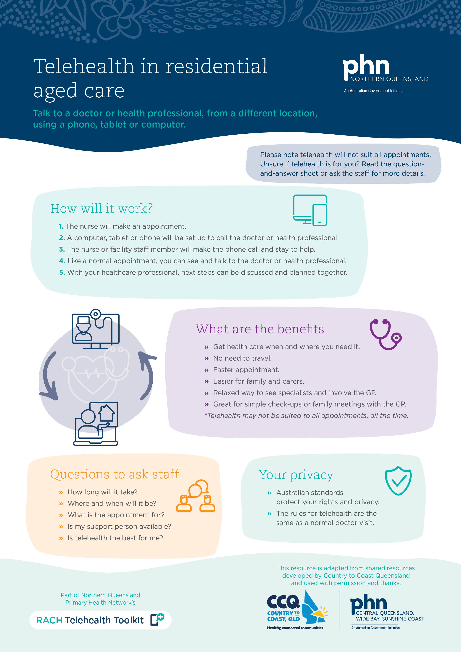

Telehealth pamphlet
Resource number | 3.0
Resource name | Telehealth pamphlet
Description | This template is designed to assist residents and their representatives to easily understand telehealth.
Purpose | It is a resource for staff to discuss with and give to residents and their family to help explain how telehealth may be beneficial to them and an opportunity for them to ask questions and raise concerns.
Download resource | To download this resource, click here.
Date stamp | 31 March 2025

Telehealth pamphlet
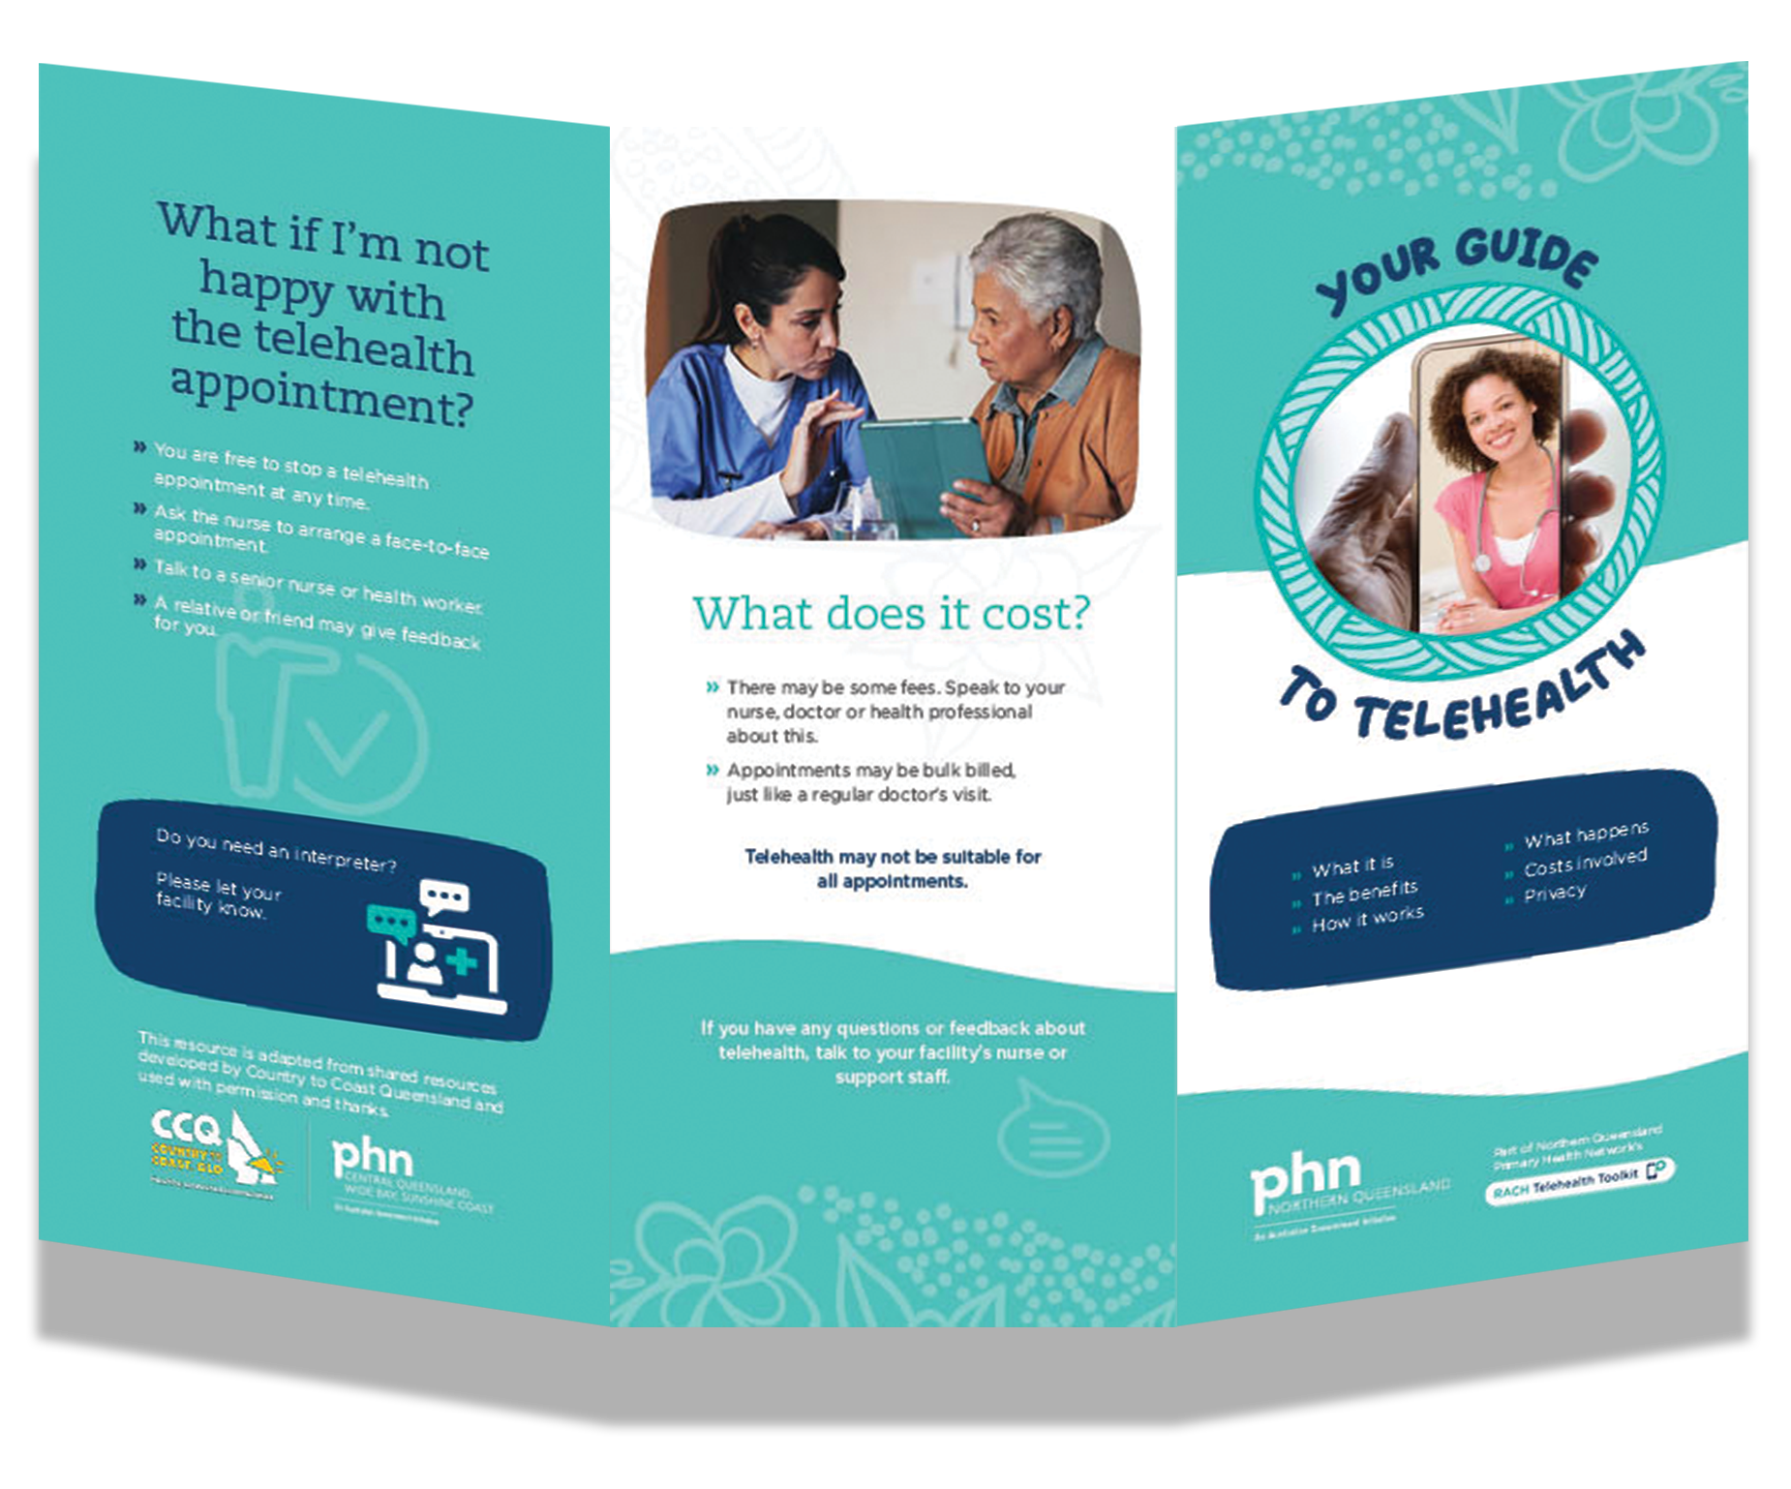

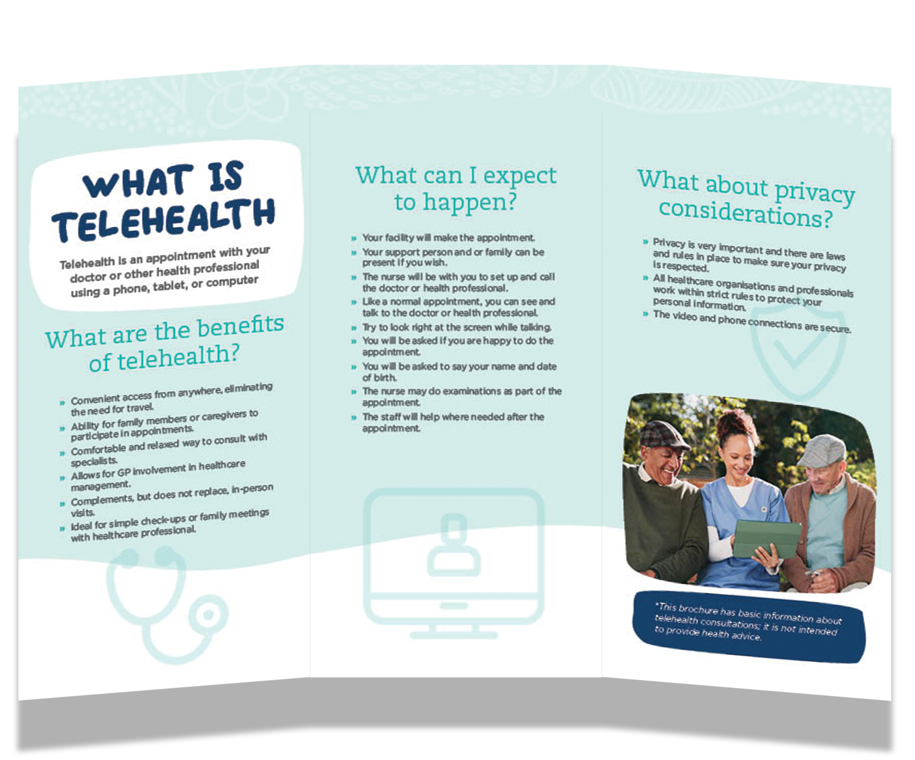

NQPHN Telehealth Cart flyer for healthcare providers
Resource number | 4.0
Resource name | NQPHN Telehealth Cart flyer for healthcare providers
Description | This flyer offers a one-page summary of the capabilities of telehealth carts provided to RACHs by NQPHN.
Purpose | This flyer is designed to help you easily introduce your healthcare providers to the Visionflex telehealth carts.  It highlights the cart’s key features, and the clinical tools included, providing a quick and concise overview of its capabilities. The content is tailored to deliver the most relevant information for those considering remote healthcare delivery.
Resource guide | A list of RACHs equipped with NQPHN’s telehealth bundle can be accessed by scanning the QR code on the flyer using your phone.
Download resource | To download this resource, click here.
Date stamp | 31 March 2025

NQPHN Telehealth Cart flyer for healthcare providers

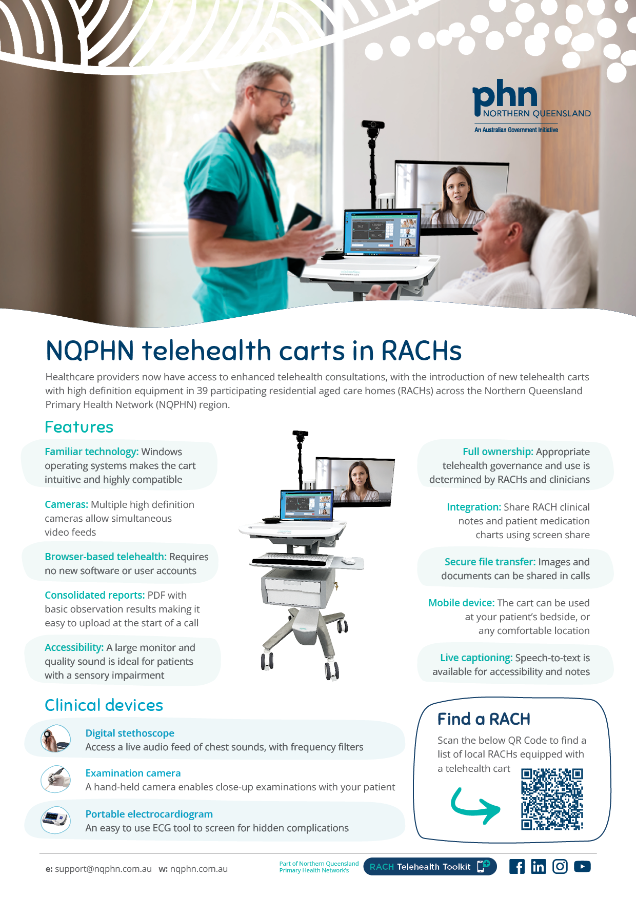

Telehealth Consultation Checklist
Resource number | 5.0
Resource name | Telehealth Consultation Checklist
Description | This template checklist is to assist RACHs with technical setup, use, and optimisation of equipment and the consultation space.
Purpose | This template checklist provides an example of five tables for RACHs to adapt for their own situation in relation to how a telehealth consultation will operate and flow.  The template includes a column called ‘location of process or guideline’, to enable staff to locate additional materials pertaining to the procedure. In this column, the RACH may record the additional file name and where it is kept. Examples are provided.  The tables in the consultation checklist include:  1. Arranging a telehealth consultation and general set-up  2. Before each consultation – room preparation  3. Before each consultation – resident preparation  4. During the consultation  5. After the consultation.  A copy of the resource developed for the RACH should remain with the telehealth equipment, for staff to access easily.
Resource guide | The following resources are source documents for this checklist template, and may support the development of a consultation checklist specific to  your facility:  - Allied Health Professionals Association – Telehealth Guide for allied health professionals.  - Australian College of Rural and Remote Medicine (ACRRM) framework for telehealth and guidelines for telehealth services.  - Business NBN – best practice telehealth set up.  Department of Health – Medicare Benefits Schedule Online privacy checklist for telehealth services.
Date stamp | 31 March 2025

Telehealth Consultation Checklist
Arranging a Telehealth consultation |  | Location of process/guideline
☐ | Review the facility’s protocols.  (e.g., clinical needs, appointments, equipment). | Example: Policy and Procedures (P&P)
☐ | Check the facility’s resources.  (e.g., contact list, resident information).
☐ | Confirm appropriateness of telehealth consultation for resident on this occasion. | Example: P&P Manual  Procedure Number TH02
☐ | Schedule an appointment with provider, advise resident, and support people.
☐ | Establish the best location for the consultation.  (e.g., quiet and private room).
☐ | Arrange technology and IT support.  (e.g., people and equipment, before and during).
☐ | Arrange dedicated Nursing cover.  (For before and during the appointment).
☐ | Resident has information about telehealth.  (e.g., time, consent, support people). | Example: Telehealth Pamphlet, Resource Number 3.0
☐ | The special needs of the resident have been considered.  (e.g., supports for people who are deaf, where English is a second language, or they identify as Aboriginal and/or Torres Strait Islander).
☐ | Document arrangements and general setup undertaken, as per facility process.
Before each consultation – room preparation |  | Location of process/guideline
☐ | Confirm appointment with doctor and relevant others.
☐ | Collect telehealth equipment.  (e.g., have tested and tagged equipment, in the room, and turned on).
☐ | Pre-test Equipment.  (e.g., check all connections and parts work).
☐ | Check Field of view.  (e.g., position the screen for comfort and eye contact).
☐ | Check Lighting in room.  (e.g., room is bright with minimal shadows).
☐ | Check Sound and Speech.  (e.g., adjust speaker volume, explain microphone).
☐ | Collect and prepare clinical records.  (e.g., observations, test results).
☐ | Collect required clinical equipment.  (e.g., dressing packs).
Continued on next page.

Before each consultation – room preparation (continued) |  | Location of process/guideline
☐ | Prepare for technology failure.  (e.g., mobile phone back-up, IT ready, tip sheet, contingency plan).
☐ | Place ‘do not disturb, consultation in progress’ sign on the door.  (after all participants have arrived).
Before each consultation – resident preparation |  | Location of process/guideline
☐ | Ensure resident’s privacy and dignity is maintained during the consult.  (e.g., 2-piece outfit, screen, gown, or cover sheet for examination).
☐ | Consider resident comfort.  (e.g., position monitor, chair, speaker, microphone, support people
☐ | Minimise distractions and background noise.  (e.g., turn phones off, close blinds).
During the consultation |  | Location of process/guideline
☐ | Introduce everyone at the beginning of the consultation.
☐ | Confirm Reason for consult, right doctor, right resident, right health record.
☐ | Confirm identity by asking resident to state their name, address, and Date of Birth.
☐ | Confirm resident’s consent to participate including others in attendance.
☐ | Session recording should be disabled.  Where this is a requirement, permission to record a video conference from everyone on the call is needed.
☐ | Confirm steps have been taken to maintain resident’s privacy.
☐ | Confirm resident’s comfort, including that they can see and hear.
☐ | Ask everyone to speak clearly into the microphone using normal tone and one person to speak at a time.
☐ | Support clinical needs - ISBAR handover, discussion, assist assessment, examination, and care planning.
After the consultation |  | Location of process/guideline
☐ | Manage follow-up by documenting and finalising notes, clinical handover, and delegating actions (i.e., scripts, pathology, next appointment, and written orders pending).
☐ | Debrief with resident by asking how they found the consult or if they have any questions.
☐ | Ask resident and family for feedback about their experience.
☐ | Return equipment to secure designated area.
☐ | Complete consultation details in telehealth consultation register.
☐ | Maintain equipment by ensuring re-charged, cleaned and ready for use.

Telehealth Consult Flowchart
Resource number | 6.0
Resource name | Telehealth Consultation Flowchart
Description | This template flowchart is to assist RACHs with technical setup, use and optimisation of equipment and consultation space.
Purpose | This template flowchart provides an example of the steps to conducting a telehealth consultation. It is for RACHs to adapt for their own situation in relation to how a telehealth consultation will flow.  The flowchart is a visual depiction of similar information described in the Telehealth Consultation Checklist (Resource number 5.0).  It includes:  - how to arrange and prepare for the consult  - what to do on the day, during and after the consultation.
Date stamp | 31 March 2025

Telehealth Consult Flowchart
Lead up to appointment






Resident requires a clinical review
☐ Review the facility's telehealth protocols.
☐ Check the facility's telehealth resources.

Make arrangements and document accordingly
☐ Confirm appointment time, platform being used, clinician name.
☐ Arrange dedicated nursing and technical support cover.
☐ Arrange translators or cultural supports as required.
☐ Document arrangements as per facility's process.
Schedule telehealth appointment
☐ Record appointment time with external clinician as per facility's appointment process.
☐ Advise resident and their family of the appointment time.
☐ Advise resident and their family there will be an opportunity to discuss the mode
of appointment prior.

Discuss mode of appointment with resident and family
☐ Resident and family are given telehealth information (verbal and written).
☐ Resident and family understands what telehealth is and have had time to ask questions.
☐ Determine if translators or cultural supports are needed to facilitate the appointment.
☐ Resident verbally consents to telehealth consultation.
☐ Advise resident where the consultation will take place.
Confirm appropriateness of telehealth appointment
☐ The resident's clinical need is appropriate for a telehealth consult per protocol.
☐ The tools and equipment are available.
☐ Staff are available.
☐ Appropriate consent obtained.


Day of consultation
Appointment and room preparation
☐ Confirm appointment with external clinician.
☐ Collect telehealth equipment and take to room.
☐ Position for best field of view lighting, and sound.
☐ Pre-test equipment and prepare back-up for possible technology failure.






After the consultation
☐ Record clinical notes.
☐ Undertake clinical handover and delegate follow-up (i.e., scripts, pathology, next appointment).
☐ Debrief with resident by asking how they found it or if they have any questions.
☐ Ask resident and family for feedback about their experience.
☐ Clean and return equipment to secure designated area.
Clinical preparation
☐ Collect and prepare clinical records.
☐ Ensure required clinical equipment is ready.
☐ Place 'Do not disturb, consultation in progress' sign on door.
Resident preparation
☐ Ensure resident's privacy and dignity will be maintained throughout.
☐ Consider resident's comfort needs.
☐ Minimise potential distractions.
☐ Ask everyone to speak clearly into the microphone, look directly at the screen.
During the consultation
☐ Introduce everybody
☐ Confirm right doctor, right resident, right health records, reason for consult.
☐ Confirm resident's identity—name, D.O.B. and address.
☐ Confirm resident's consent to participate.
☐ Session recording should be disabled. Where this is required, ask permission to record a video conference from everyone on the call.
☐ Support clinical needs, coordinate discussion, and assist with exam and care plan.

Before ending the consultation
☐ Check follow-up requirements.
☐ Clarify pathology/other tests to be ordered and who will be responsible.
☐ Ensure resident does not have any further questions.
☐ Check if another appointment is required including the mode.

Consultation in progress sign
Resource number | 7.0
Resource name | Consultation in progress: Do not disturb sign
Description | This template Sign is to assist facilities with technical setup, use and optimisation of equipment and consultation space.
Purpose | The function of the sign is to maintain privacy for the resident when a consultation is in progress.  The sign, developed for the RACH, should remain with the telehealth equipment, for staff to access easily.
Download resource | To download this resource, click here.
Date stamp | 31 March 2025

Consultation in progress sign


Telehealth Technology Support template
Resource number | 8.0
Resource name | Telehealth Technology Support template
Description | This template is to increase staff understanding in how to manage technical risks and issues relating to IT (information technology) functionality and performance.
Purpose | This template provides an example of four tables for RACHs to adapt for their own situations in relation to the information technology (IT) in use for telehealth consultations.  The tables include:  1. Internet Provider and Videoconferencing Software Access  2. Equipment Checklist and Maintenance Schedule  3. Technical Assistance and Support Contacts  4. Service Contractor Register.  A copy of the resource developed for the RACH, should remain with the telehealth equipment, for staff to access easily.
Date stamp | 31 March 2025

Telehealth Technology Support template
Table 1: Internet Provider and Videoconferencing Software Access
Internet/Software | Description | Username | Password
Internet connection type: | e.g., NBN, ADSL, Wi-Fi
Generic email address access:  (Office 365 email accessible by all is recommended) | Generic email address for telehealth appointment links
Videoconferencing Software: | e.g., Skype, Teams, Zoom, Healthdirect, Vision | Generic email address for appointments advised
Wi-Fi Access – secure: | Visiting GPs and other providers
Other:

Table 2: Equipment Checklist and Maintenance Schedule
Equipment/device register | Unique Identifier and Location | Username and password | Maintenance Schedule  Include testing and tagging, cleaning, detecting, diagnosing, and fixing problems
Computer
Laptop
Tablet/smart device
Webcam
Monitor
Speakers
Mobile phone
Microphone
Secure store/charge area
Power cords/cables

Table 3: Technical Assistance and Support Contacts
Type of support | Company name | Hours of operation | Contact details
Healthdirect Video Call | Video Call Service Desk | 08.00 – 18.00 | 1800 580 771  videocallsupport@healthdirect.org.au
Vision Telehealth Platform | Visionflex Support | 09.00 – 17.00 | (02) 8914 4000  support@visionflex.com
Queensland Health Telehealth Portal | QH Telehealth Service Desk | 08.00 – 17.00 | 1800 066 888  telehealthservicedesk@health.qld.gov.au

Table 4: Service Contractor Register
Type of service¹ | Service provider | Contact details

¹ Annotation – More than one service contractor may deliver all or a portion of functions, such as:
1. | General non-urgent support | Call-in technician to conduct routine equipment upkeep and fix hardware problems (to enable planning for outages and maintenance)
2. | Remote IT services | Contract for Software updating network administration and security protocols
3. | End-user support | IT support person who is available to staff, either on-site or remote (e.g., for nurses requiring immediate support during consultation)
4. | Emergency IT services | Contract for emergency IT services with a local provider, to provide a service within a narrow and defined time-period.

Troubleshooting Guide
Resource number | 9.0
Resource name | Troubleshooting Guide
Description | This resource is to increase staff understanding in how to manage technical risks and issues relating to information technology (IT) functionality and performance.
Purpose | The troubleshooting guide lists common situations that arise during telehealth, and problem-solving steps to overcome these issues.  Note, this is a generic troubleshooting guide.  Guides for software specific troubleshooting are accessible on the relevant software vendors website. In addition, see Resource Number 10.0 Platforms and Software User Guides, contained within this toolkit.  A copy of this resource should remain with the telehealth equipment of the facility for staff to access easily.
Date stamp | 31 March 2025

Troubleshooting Guide
Situation | Contingency plan
Be prepared for technical issues during a consultation | - Have contact details for other parties available.  - Have a mobile phone ready to contact the provider to discuss and plan how to continue.  - Be familiar with how to dial in others if it is decided to continue by phone.  - Have weblinks and web resources available for easy access (ensure staff are familiar with these sites).  - Regularly review back-up contingencies for efficiency/effectiveness.
Unable to be seen or cannot see the other person | You or they check the camera icon.  - Click on the camera icon.    - If the camera is on and still unable to be seen, try disconnecting and reconnecting into the call. Let the others know what you are doing first.
The other person cannot hear you | You or they check the microphone (mic) icon.  - Click on the mic icon.    - If the mic is on and still unable to be heard, try disconnecting and reconnecting into the call. Let the others know by sending a chat or text message first.
Unable to hear the other person | - Check the volume on the telehealth device or speaker being used is on and high enough.  - Ask the person on the other end to check their mic (as above).  - If the above does not resolve this, try disconnecting and reconnecting into the call and advising the other person to do the same. Let the others know by sending a chat or text message first.
Background noise interfering with hearing | - If it is on your end, let the others know you will mute your mic and turn back on or wave your hand when you wish to speak.  - If the background noise is on the other end, ask them to mute the mic and turn back on or wave their hand when they wish to speak.
Audio is poor/ difficult to hear each other | - Mute the audio and proceed with video and use a phone for audio communication.
Problems with the quality of a video consultation | - Turn the video off and proceed with audio only.  - If possible, turn video on for short periods only as needed i.e., to check a wound.  - Ensure adequate lighting and avoid direct sunlight from windows.
Technical issue or technical failure during consult – unable to fix or other options have not worked | - Complete the interrupted consultation by phone, or  - Reschedule the consultation if non-urgent.

Telehealth platforms and software user guides
Resource number | 10.0
Resource name | Telehealth platforms and software user guides
Description | This resource is to support staff in understanding how to effectively use telehealth platforms and software.
Purpose | This template provides a list of platforms commonly used by RACHs in the northern Queensland region including online links to their software guides.  • Zoom.  • Skype.  • Queensland Health telehealth portal.  • Facetime.  • Microsoft Office Teams.  Two other established platforms have been included in this template under endorsement by NQPHN for secure telehealth:  • healthdirect Video Call  • Vision (by Visionflex).
Date stamp | 31 March 2025

Telehealth platforms and software user guides
No. | Platforms | Software User Guides  Use preferred Search Engine to access user guides and manuals.  Click on the URL links below
1. | healthdirect Video Call | healthdirect Video Call – Aged Care Portal  RACH Technology and Trouble Shooting – healthdirect Australia
2. | Vision (Visionflex) | Visionflex Quick Start Guide  Visionflex Support
3. | Queensland Health Telehealth Portal | Telehealth portal patient quick reference guide
4. | Zoom | Zoom for Healthcare
5. | Skype for Business | https://support.microsoft.com/en-us/skype-for-business
6. | Facetime | https://support.apple.com/en-us/HT204380
7. | Microsoft Teams | How to use MS Teams for telehealth

Telehealth software comparison
Resource number | 11.0
Resource name | Telehealth software comparison
Description | This table presents a comparison of telehealth software which may be helpful in deciding how to conduct telehealth.
Purpose | This information was compiled by PHNs following research into options available for RACH telehealth at the beginning of the initiative.  Some information may be outdated, but RACHs may find it a useful starting point to identify and direct further research into alternative options to the Vision subscriptions pre-paid by NQPHN.  As Vision subscriptions expire, RACHs will be responsible for continued payments for Vision, or for choosing their preferred alternative method for ongoing telehealth engagement.
Resource guide | This resource was developed from materials sourced originally from the Hunter New England and Central Coast PHN.
Download resource | To download this resource, click here.
Date stamp | 31 March 2025

Telehealth software comparison
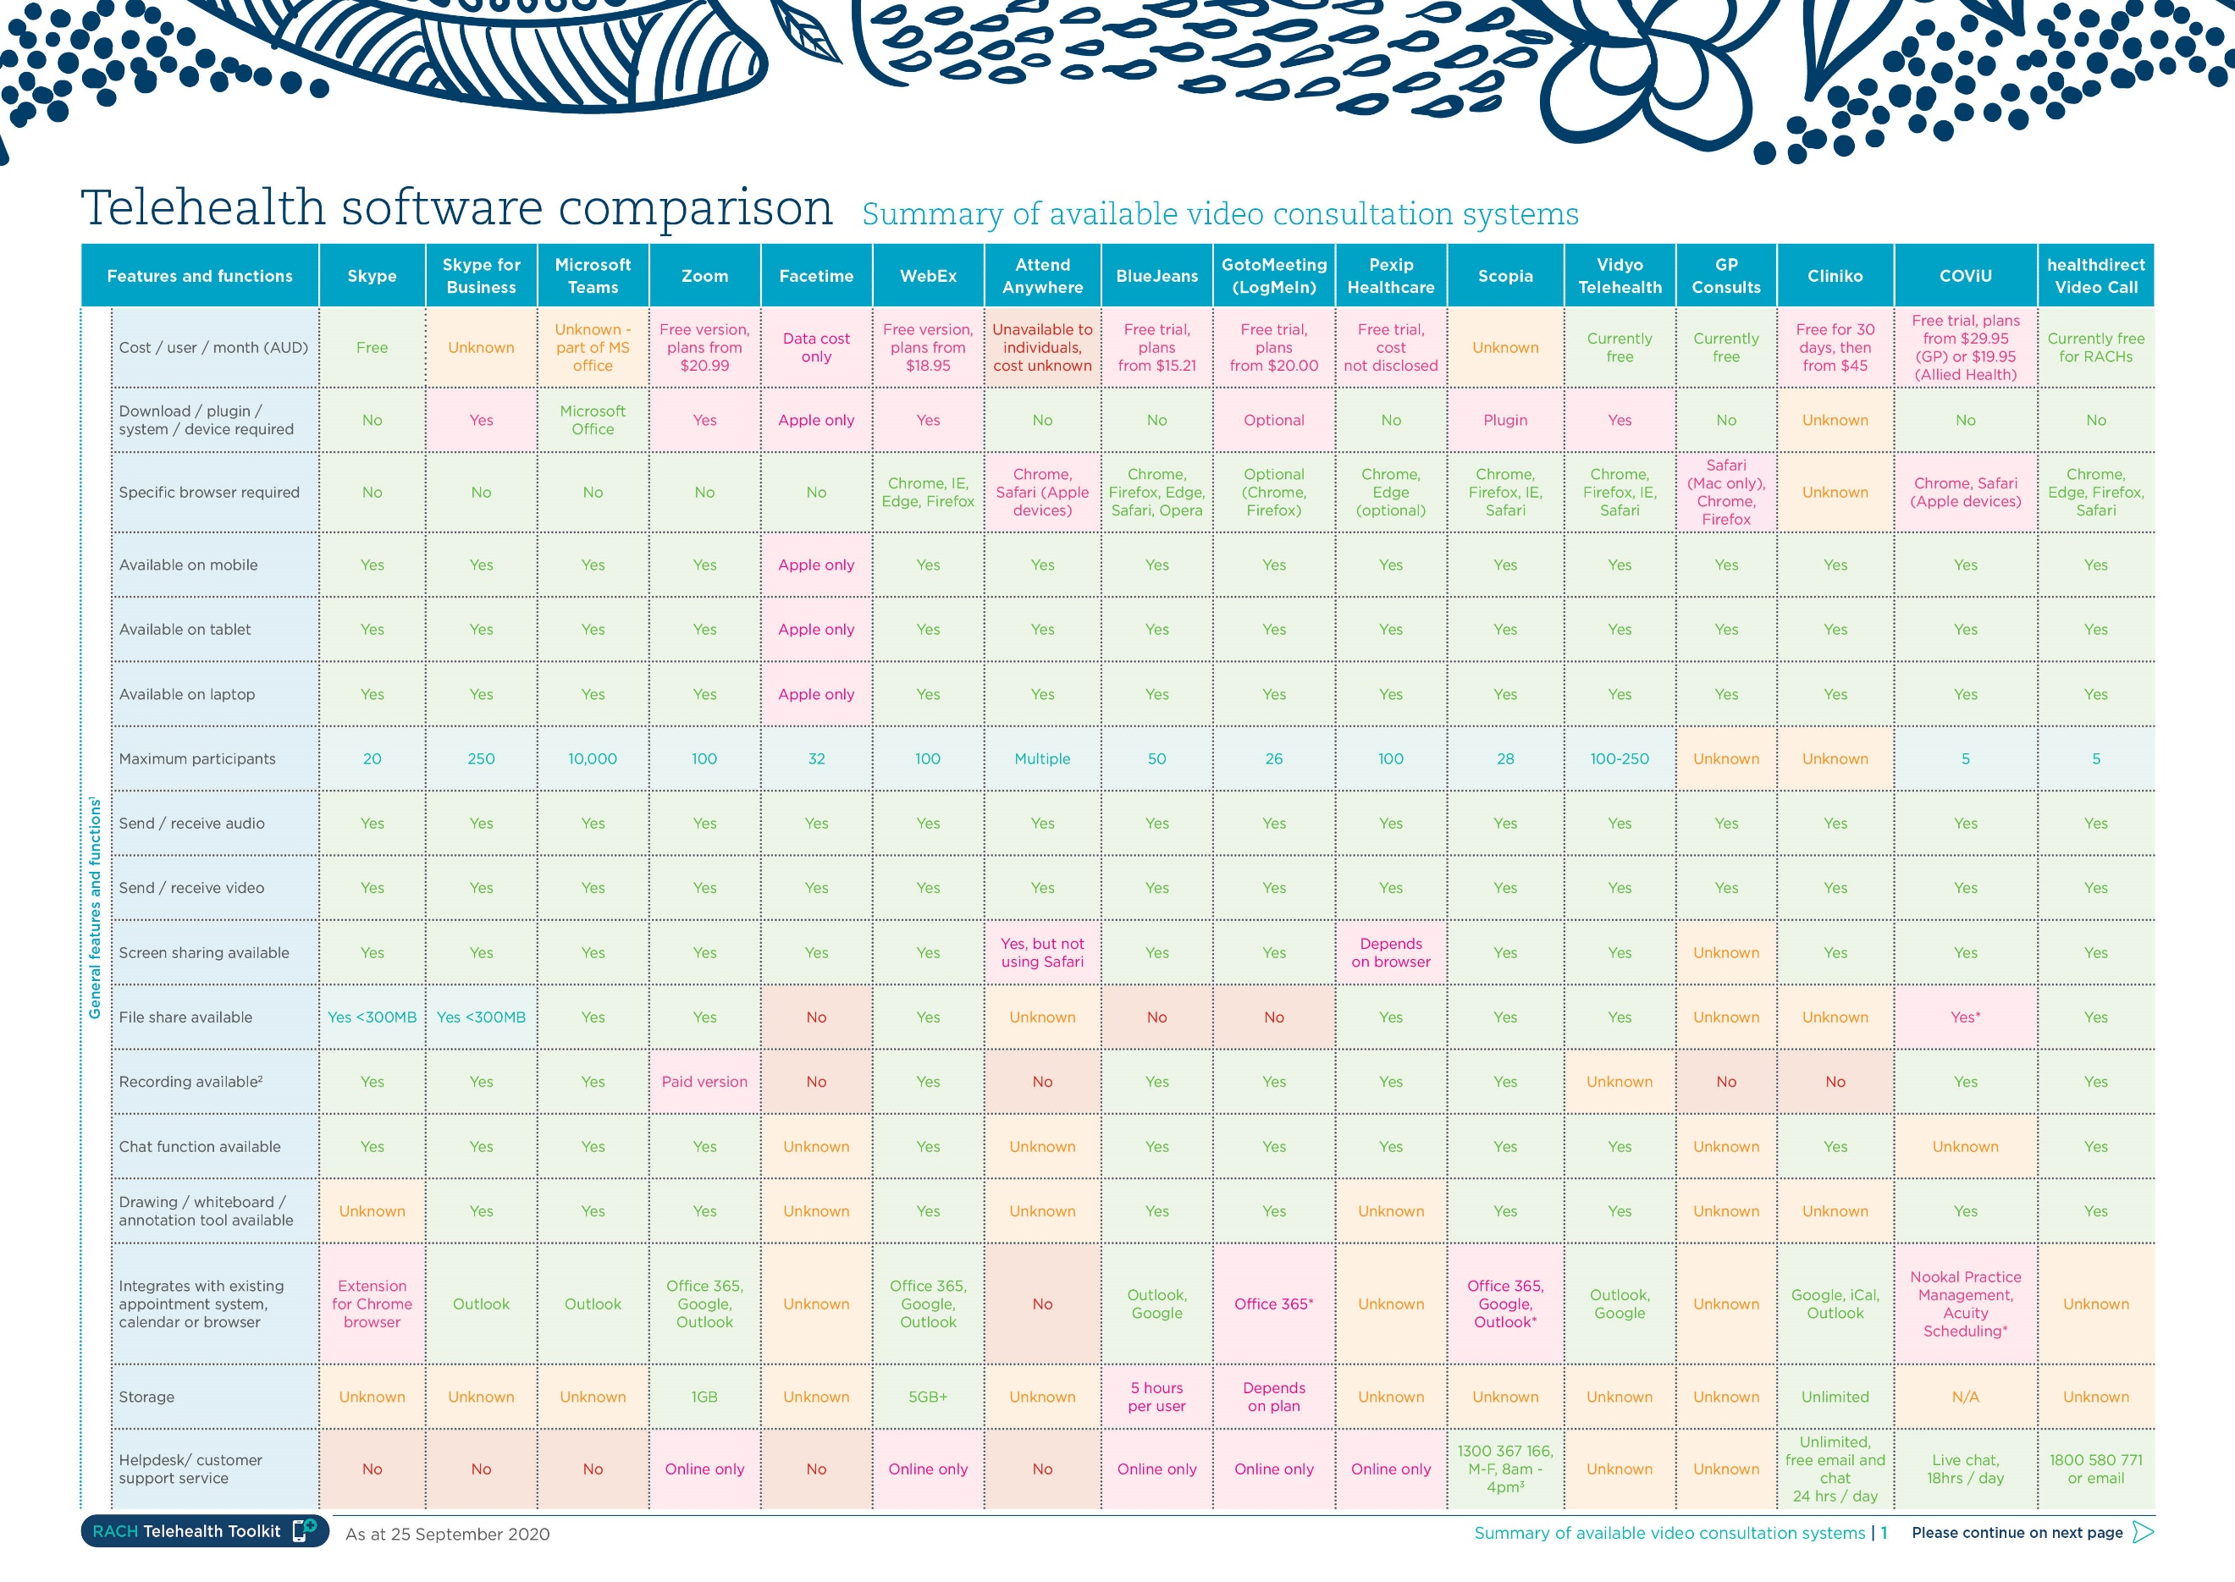

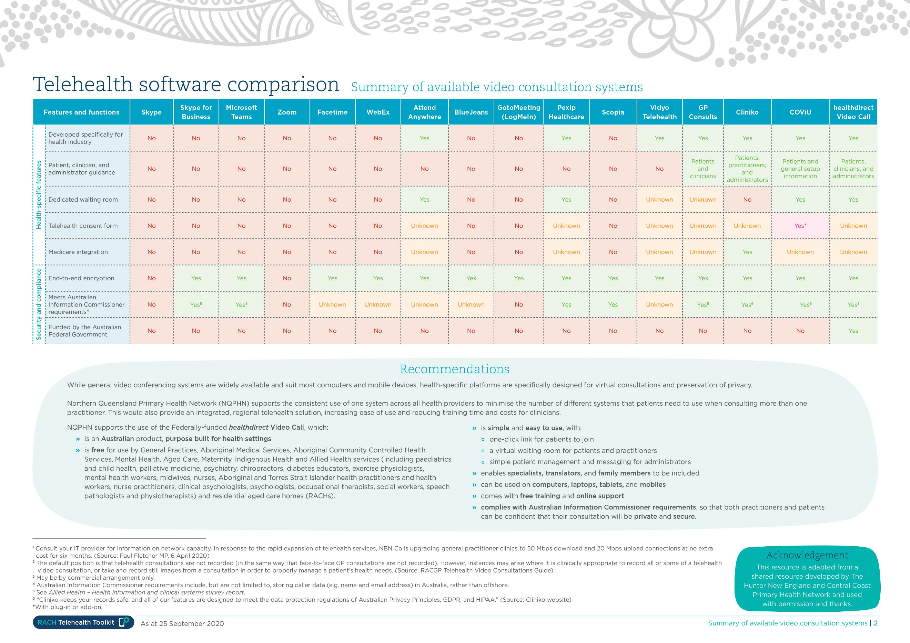

Consent guide and template
Resource number | 12.0
Resource name | Consent guide and template
Description | This guide template is to support clinical care before, during and after telehealth consultations.  Note: This template is an example only and may not suit all contexts of care.
Purpose | This resource provides the facility with an example one-page document to discuss telehealth information with the resident and their family, and to obtain consent.  It is to support the development of a consent form appropriate for your RACH.  The information provided is to be used as a starting point for RACHs to adapt to their own situation and to determine essential points for inclusion.  If a person chooses to take part in the telehealth consultation, they, or their representative should sign a consent form to give official documented consent, which is to be retained by the facility.  This guide template comprises three sections for facilities to consider when creating a specific telehealth consultation consent form.  The sections are:  1. Introductory paragraphs describing telehealth value, risks, and choices  2. Signature area  3. Extra consenting option if recording video or capturing images.
Resource guide | The following resources are source documents for this template, and may support the development of a consent form specific to your facility:  • The template is based on the Allied Health Professionals Australia, Telehealth Guide for Allied Health Professionals, May 2020, page 20.  • Australian Commission on safety and quality in healthcare, Informed Consent.  • Queensland Health, Informed Consent.
Date stamp | 31 March 2025

Consent guide and template
Consent overview
1. | Explain the value of having a phone or video consult, such as:
1. | - Reduce the waiting time for the resident to see their healthcare professional.  - Avoid the need for the resident to travel to see their healthcare professional.  - Manage the health of the resident when they cannot visit their healthcare professional in person.
2. | Explain the risks of having a phone or video consultation, such as:
2. | - The consultation will not be the same and may not be as complete as an in-person service.  - There could be some technical problems that affect the consultation.  - This Healthcare service uses safeguards to protect the privacy and security of the phone or video consultation. These safeguards meet Australian standards. The risk of outside people hacking or tapping into the call does exist, but it is small.
3. | Describe the choices about healthcare received via phone or video consultation, such as:
3. | - The resident has a choice about what to do next if this consult does not work out well.  - The resident can change their mind and stop using phone or video consultations at any time.  - This includes in the middle of a consult. This will not affect their right to ask for and receive healthcare.

Signature area
I agree to have phone or video consultations with:

Date:

Name of resident:

Signature of Resident/Authorised Representative:

Additional Consent for Recording Video or Images
I agree to have this video consultation recorded, or to have photos taken.
☐ Yes, signature required below.
☐ No.

The [insert facility name] will manage and store this material securely, meeting Australian Standards. It is only for use to assist my health care. I have the right to see the video or images, and to receive a copy for a reasonable fee. I understand that the service cannot ensure total safety against hacking or tapping into the recording by outside people.

Signature of Resident/Authorised Representative:

Complementary services template
Resource number | 13.0
Resource name | Complementary services template
Description | This template is to increase staff understanding in how to effectively support clinical care for residents and family before, during and after telehealth consultations.
Purpose | This template is to help facilities to create a list of complementary service contacts to assist staff in offering support for residents and streamlining telehealth services for the differing needs of individual residents.  The template offers a structure for displaying support service contact detail in rows, depending on needs and local availability. Two support services that might facilitate an improved experience for residents and their family are given as examples.  Examples of other complementary services may support:  • Aboriginal and Torres Strait Islander residents and their families through the local Aboriginal Medical Service or the National Aboriginal Community Controlled Health Organisation  • Residents with culturally and linguistically diverse backgrounds through refugee health agencies or partners in culturally appropriate care  • The National Relay Service for residents who are deaf or find it hard to hear or speak, or others who would benefit from local Interpreters.
Date stamp | 31 March 2025

Complementary services template
No. | Support services | Website | Telephone
1. | Translating and Interpreting Service (TIS) National | Translating and Interpreting Service (TIS National) | 131 450
2. | Vision Australia | Vision Australia Resources | 1300 84 74 66
3.
4.
5.
6.

Feedback question examples and reporting templates – residents and staff
Resource number | 14.0
Resource name | Feedback question examples and reporting templates – residents and staff
Description | These templates assist the development and implementation of organisational processes to support the effective use of telehealth.
Purpose | This template provides guides to developing feedback processes and two drafts of example questions to better understand the telehealth experience from the perspective of residents and staff. The example question sets are deliberately brief to make them easy to complete and to interpret. RACHs may decide to adapt their existing service feedback forms and processes. The RACH should consider which key pieces of information they receive from residents and staff will help to improve the service.  This resource consists of a:  1. Guide to developing a questionnaire  2. Guide to scoring responses  3. Resident Feedback example  a) Sample questions  b) Reporting template  4. Staff Feedback example  a) Sample questions  b) Reporting template  Annotations in the templates provide additional questions the facility may choose to include to identify quality improvement opportunities.
Resource guide | 1. South Australia Digital Telehealth Network  2. Queensland Health Patient reported experience measures  If you would like assistance in developing and managing feedback processes, contact NQPHN’s Older Persons Health and Palliative Care team at ophapc@nqphn.com.au
Date stamp | 31 March 2025

Feedback questionnaires and reporting
Guide to developing questionnaires
1. | When developing a feedback questionnaire:
1. | - Keep questions and words simple and easy to read.  - Give a range of answer options rather than free text responses.  - Consider how easy it is for the residents to complete and how easy it will be to evaluate.  - Allow space for comments.  - Decide if using paper based, electronic or a mix of both when seeking feedback.
2. | When asking residents and their family to provide feedback, explain:
2. | - Why their feedback is important and valuable.  - What the feedback is for, such as improving the telehealth service.  - Whether results will be shared with others outside the facility (i.e., external providers).  - That confidential information is never shared.  - The facility is grateful for their time and effort in providing feedback.  - Where to place or how to send their completed feedback.
3. | Consider how the feedback will be managed, for example:
3. | - Being clear about the reason for every question, what will the answers reveal, and how emerging issues will be handled.  - Safe collection and storage of feedback.  - How the information will be analysed and reported, and who will be responsible.  - How feedback will align with existing compliments and complaints processes.  - What will be done with the results, such as quality improvements, PDSA cycles.  - Scan qualitative (free text, verbal) feedback and consider what will be done with the results as per above point.
Guide to scoring and reporting
1. | How to score each quantitative question:
1. | - Agree = visual which numerically equals 5.  - Not Sure = visual which numerically equals 3.  - Disagree = visual which numerically equals 1.  - The higher the score, the higher the level of satisfaction.
2. | Scoring Satisfaction Rating:
2. | - For each respondent’s form, score the response to each question.  - Transcribe scores to the report template, one row per respondent allocating a score 1,3,5 as described above.  - Average the satisfaction score for each respondent in last shaded column in template.  - (Sum of scores divided by number of questions answered).  - Average the satisfaction score for each question in last shaded row in template.  - (Sum of scores divided by the number of responses).  - The lower scoring questions should be seen as opportunities for improvements.  - To determine overall satisfaction with the telehealth service by the cohort of respondents in the report, average the final column.  - Consider setting a target Satisfaction Rating.

Resident feedback question examples
No | Thinking about your telehealth consult, how much do you agree with the following? | Circle your answer |  |  | Comments
No |  | Agree=5 | Not sure=3 | Disagree=1 | Comments
1. | Staff gave me enough information about how it would work before starting the consult
2. | I was able to tell my story
3. | The standard of care was the same as a face-to-face visit
4. | The equipment worked well
5. | I would like to use telehealth again
6. | Do you have anything else to tell us about the telehealth service?

Thank you for taking the time to complete this feedback.

Annotation – Other telehealth experience questions to consider
1. | The consult was held in a private place
2. | I felt at ease during the consult
3. | My chosen support people were with me
4. | It was about me as a whole person
5. | I helped make the plan of action
6. | I could hear well enough
7. | I could see the other person well enough
8. | Overall, I am happy that I had this consult
9. | What was the best thing about the telehealth consult?

Resident scoring template example
Example Summary report ‒ Refer to Scoring guide resident satisfaction
Response number | 1.  Understanding before starting | 2.  Able to tell own story | 3.  Same standard as F2F | 4.  Technology worked well | 5.  Will use telehealth again | Average score per resident feedback
1.
2.
3.
4.
5.
6.
7.
8.
9.
10.
Average score per question |  |  |  |  |  | Aggregate Score

Staff feedback question examples
No | Thinking about telehealth consultations, how much do you agree with the following? | Circle your answer |  |  | Comments
No |  | Agree=5 | Not sure=3 | Disagree=1 | Comments
1. | I know enough about how telehealth works to prepare residents for their consult
2. | The systems and processes in place for telehealth are useful
3. | I feel confident helping residents during telehealth
4. | I feel confident using the telehealth equipment
5. | Telehealth consults are the same or better than face-to-face visits
6. | Do you have any other comments about telehealth?

Thank you for taking the time to complete this feedback.

Annotation – Other feedback questions to consider asking staff
1. | Telehealth processes are efficient
2. | Telehealth equipment/technology is reliable
3. | Staff are benefitting from having telehealth services for their residents
4. | Telehealth is improving resident health outcomes
5. | Telehealth is reducing hospital admissions / emergency department visits
6. | Telehealth is increasing access to GP / health care
7. | Overall residents are benefitting from telehealth services

Staff scoring template example
Example Summary report ‒ Refer to Scoring guide staff satisfaction/confidence
Response number | 1.  Satisfied with telehealth knowledge | 2.  Satisfied with systems and processes | 3.  Confident helping residents | 4.  Confident using equipment | 5.  Confident telehealth is same/better than F2F | Average score per staff feedback
1.
2.
3.
4.
5.
6.
7.
8.
9.
10.
Average score per question |  |  |  |  |  | Overall Score

Register of telehealth consultations
Resource number | 15.0
Resource name | Register of telehealth consultations
Description | This template is to assist the development and implementation of organisational processes to support the effective use of telehealth.
Purpose | This template is to provide staff with an easy log to track and monitor telehealth consultations. An example report template is also provided.  An annotation to this register template has additional reporting elements the facility may choose to include to identify quality improvement opportunities.  The facility may incorporate this register into existing processes for managing resident appointments external to the facility. Alternatively, simply adding a telehealth field to your RACHs existing consult log may suffice.
Date stamp | 31 March 2025

Telehealth consultations log example
- Number | - Date | - External provider | - Location  of consult | - Technology/  equipment worked well | - Equipment returned and ready for use | - Comments | - Name and Signature
Response options for completing log
Sequential order | Date of consult | - GP  - Specialist  - Allied Health Professional  - Mental Health professional  - Other (describe) | - Consult room  - Bedside  - Other (describe) | - Yes  - No (describe) | - Yes  - No (describe) | Descriptions and other information | Staff member responsible for consult

Annotation – Additional items to consider for consultation register
No | Question | Response option
1. | Technology used | Computer, Laptop, Smart device, Mobile phone, Webcam, Monitor, Speaker, Microphone.
2. | Technical issues | Video quality, Audio quality, Connection quality, Equipment issues (either end).
3. | Clinical equipment used | Exam camera, Portable ECG/heart, Augmented reality, Digital stethoscope, IR thermometer, BP monitor, Pulse oximeter.
4. | Reason for consult | Pain Management, Falls Management, Wound Care, Care planning, Medications, Palliative care, Other.
5. | How did the consult seem for resident? | Positive experience, Satisfactory Experience, Negative experience, Unclear.
6. | What would have made the consult more efficient? | More time, More help, Resident support, Equipment, Knowledge, Other.
Telehealth consultations log example
Number | Requested information | Response options | Sum responses
1. | Number of consults
2. | Date range of report period
3. | External provider | - General Practitioner
3. | External provider | - Specialist Medical Professional
3. | External provider | - Allied Health Professional
3. | External provider | - Mental Health Professional
3. | External provider | - Other
4. | Location | - Consult room
4. | Location | - Bedside
4. | Location | - Other
5. | Technology/equipment worked well | - Yes
5. | Technology/equipment worked well | - No
6. | Equipment is returned and ready for use | - Yes
6. | Equipment is returned and ready for use | - No

