Continuous quality improvement
Register

Why is Continuous Quality Improvement (CQI) important?
Improving your practice’s structures, systems, and clinical care using data-driven insights enhances both patient safety and care quality. Engaging the entire practice team in safety and quality systems is key to successfully implementing quality improvement initiatives.

Meeting accreditation quality improvement standards
Maintaining a quality improvement plan and register can help track activities, their outcomes, and areas for further improvement. This approach allows your practice to:
- determine whether improvements were effective or if further action is needed
- minimise duplication of effort and save time
- assess the efficiency of quality improvement activities
- provide a valuable learning tool for team members involved in CQI
- by integrating CQI into daily practice, your team can drive meaningful, ongoing improvements in patient care.

Planned and agreed upon data CQI activities  What data focus and/ or patient care outcomes do we have? |  |  |  |  | Planned and agreed upon physical CQI activities  What physical practice focus and/or patient safety outcomes do we have?
Data CQI activity/ area of focus for data improvement/ patient care improvement | Lead and others involved | Timeline (start-finish date) | Outcomes/ improvements achieved |  | Physical CQI activity/ area of focus to improve patient safety or care needs | Lead and others involved | Timeline (start-finish date) | Outcomes/ improvements achieved
What worked well this year? Did we reach the desired outcome? |  | What can we improve on next year? (eg process, communication, team involvement, etc) |  |  | What worked well this year? Did we reach the desired outcome? |  | What can we improve on next year? (eg process, communication, team involvement, etc)

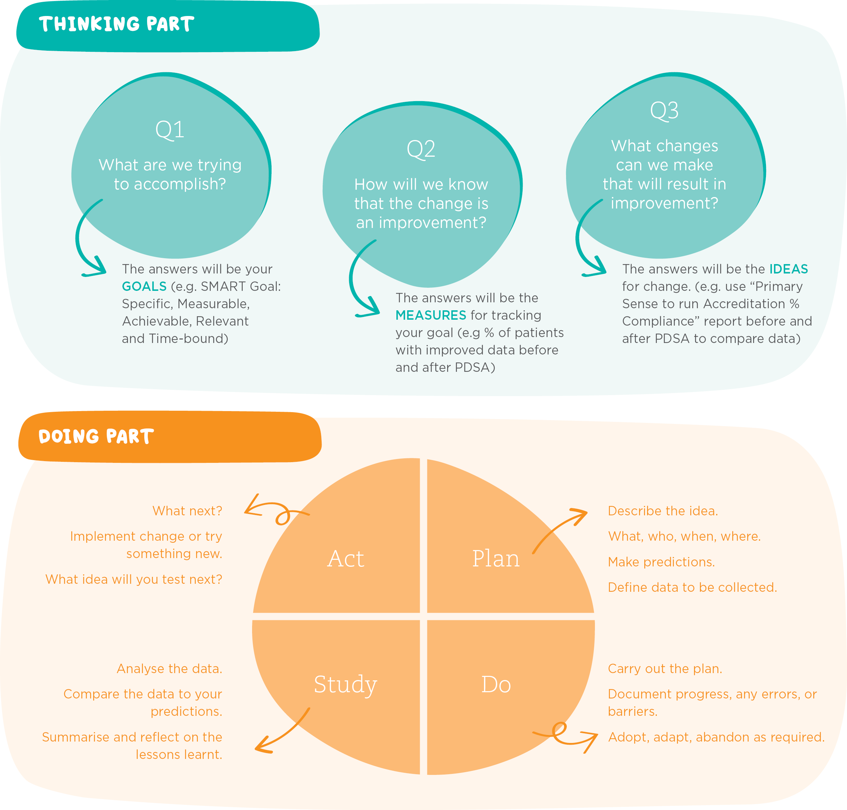
PDSA diagram

