Continuous quality improvement

Yearly planner template

|  |  |  |  |  |  |  |  |  |  |  |  |  |
| --- | --- | --- | --- | --- | --- | --- | --- | --- | --- | --- | --- | --- |
| Year: | **PIP Q1** | | | **PIP Q2** | | | **PIP Q3** | | | **PIP Q4** | | |
| Aug | Sep | Oct | Nov | Dec | Jan | Feb | Mar | Apr | May | Jun | Jul |
| Activity: |  |  |  |  |  |  |  |  |  |  |  |  |
| Activity: |  |  |  |  |  |  |  |  |  |  |  |  |
| Activity: |  |  |  |  |  |  |  |  |  |  |  |  |
| Activity: |  |  |  |  |  |  |  |  |  |  |  |  |
| Activity: |  |  |  |  |  |  |  |  |  |  |  |  |
| Activity: |  |  |  |  |  |  |  |  |  |  |  |  |
| Activity: |  |  |  |  |  |  |  |  |  |  |  |  |
| Activity: |  |  |  |  |  |  |  |  |  |  |  |  |
| Activity: |  |  |  |  |  |  |  |  |  |  |  |  |
| Activity: |  |  |  |  |  |  |  |  |  |  |  |  |

**Tip:** You can print this yearly planner and highlight activities or simply put an “x” in the month fields.

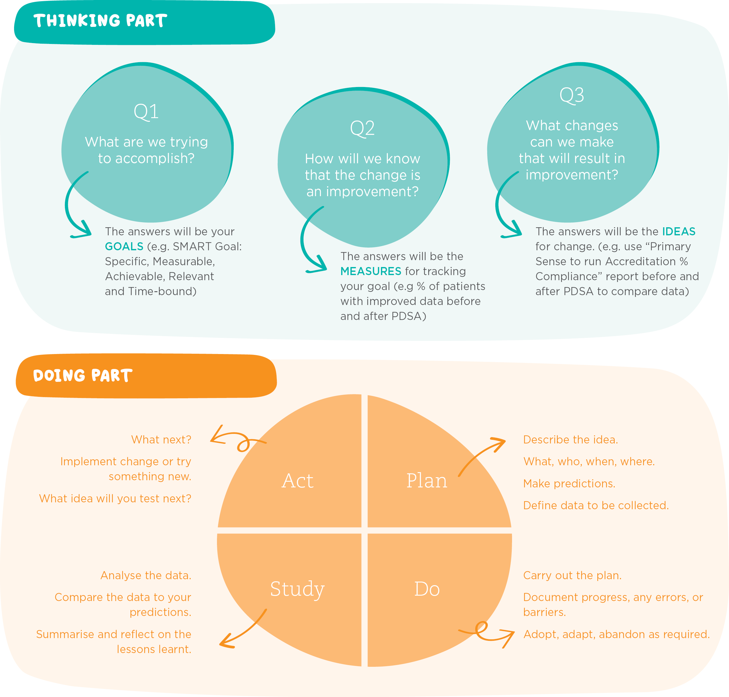PDSA diagram