Continuous quality improvement

PDSA template

|  |  |  |  |  |  |  |  |
| --- | --- | --- | --- | --- | --- | --- | --- |
| **Continuous quality improvement area** | | | | **Date of PDSA cycle** | | | |
|  | | | |  | | | |
| **Goal**  What is the goal we are trying to achieve? | | **Measures**  What measures will we use to track the achievements of our goal? | | | | **Ideas for change**  What are we wanting to change? | |
|  | |  | | | |  | |
| **PDSA: Plan – Study – Do – Act** | | | | | | | |
| **IDEAS**  What idea are we evaluating?  What change can we make that will result in improvement? | **PLAN**  How are we going to achieve our goal (who, what, when, where) | | **DO**  Was the plan completed?  What did you do? Were there unexpected events or outcomes? | | **STUDY**  Record, Analyse and Reflect on the results. Did your plan result in an improvement? By how much/little? | | **ACT**  What actions will you take, or system changes will be made?  (Adopt, Adapt, Abandon) |
|  |  | |  | |  | |  |
|  |  | |  | |  | |  |
|  |  | |  | |  | |  |

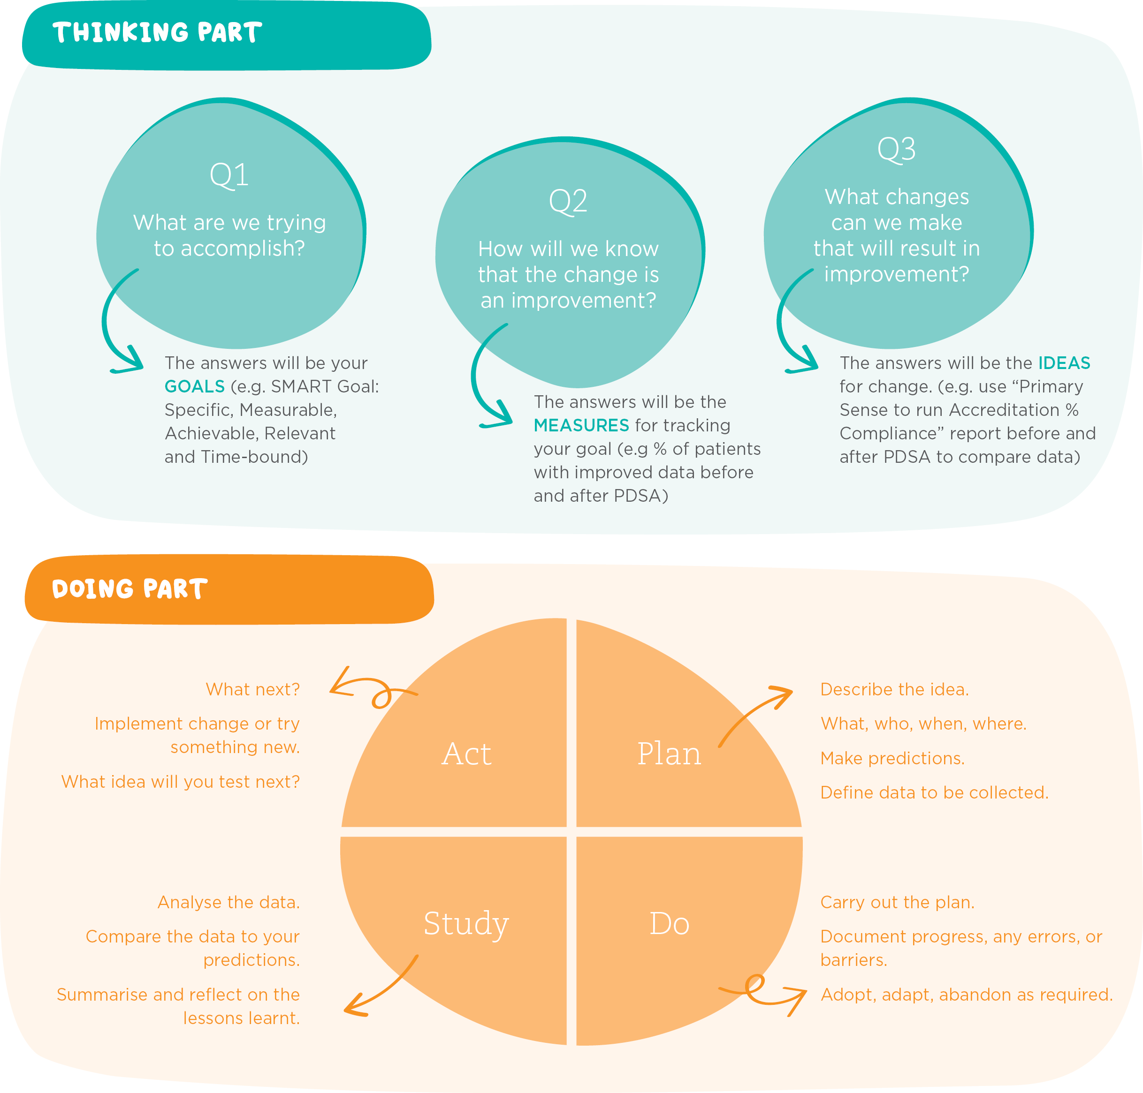PDSA diagram