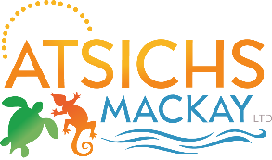

Security Person

Aboriginal & Torres Strait Islander Community Health Service (ATSICHS) Mackay Ltd is seeking interest from a Licensed Security Person to Provide high quality, timely and appropriate levels of security, fire protection and safety services to the Aboriginal and Torres Strait Islander Community Health Service Mackay Ltd, Bucasia Clinic as required to ensure the protection of persons, the protection of property, the prevention of crime, the preservation of the peace and the protection of information.
Working with ATSICHS Mackay Ltd is an opportunity to contribute to providing outstanding health services to the Mackay region. We are committed to best practice and continuous quality improvement and encourage staff to take advantage of training and development opportunities.
Hours of Work will be Monday and Wednesday from 5.30pm to 9.30pm and Saturday from 2pm to 5pm. These hours may increase due to demand for services.
Salary is negotiable.
Please contact our HR Officer, Amanda Prewett on
07 49 579 416 or hr@atsichs.or.au for further information and to obtain an application package.

