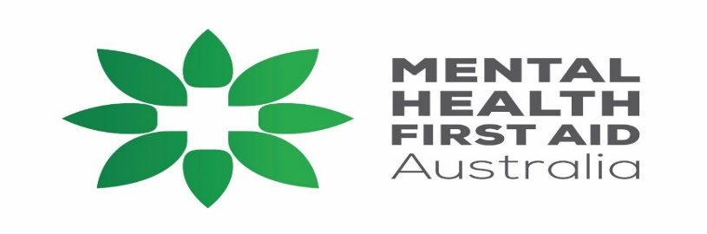
Standard Mental Health First Aid 2023 Program
Learn how to provide mental health first aid to adults
Course Overview:
The Standard (Adult) Mental Health First Aid (SMHFA) course will teach you how to assist adults who may be experiencing a mental health problem or mental health crisis until appropriate professional help is received or the crisis resolves, using a practical, evidence-based action plan. Suitable for health professionals, support workers, front line workers, administration staff and others interested in being better able to help adults with mental health problems.
Duration and format: This is a 14-hour face to face training which is usually delivered as a 2-day training package – can be delivered as 4 separate modules.
Why attend an MHFA course? Evaluations consistently show that SMHFA training is associated with improved knowledge of mental illnesses, their treatment and appropriate first aid strategies, and confidence in providing first aid to individuals with mental illness. It is also associated with decreased stigma and an increase in help provided.
Training content-at completion of the course you will have practical skills and knowledge to:
- Recognise common mental health problems in adults (depression, anxiety, eating disorders, psychosis, and substance use problems)
- Provide initial help using a practical, evidence-based action plan
- Seek appropriate professional help, and
- Respond in a crisis.
Registration: Contact Garry Batt-e: gobatt55@gmail.com or m: 0458578271

Please note RSVP by 15th June 2023
DATES: 22nd and 23rd June 2023
TIMES: 9am – 4:30pm
VENUE: Laurie Hourigan Conference Room, 41 Brisbane St Mackay (enter at the rear of the property)
FACILITATOR: Garry Batt ( gobatt55@gmail.com)
Cost: $225 per person:
Inclusions: Certificate of Completion, course manual and other resources, tea/coffee, fruit and snack food, eligibility to become a Mental Heath First Aider

