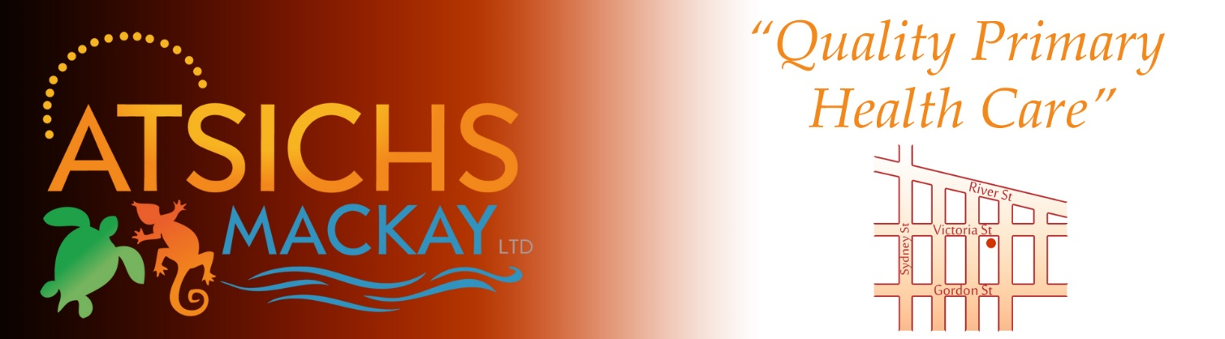
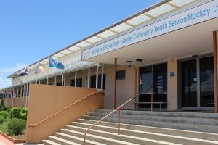

Position: GP to Join a Dynamic Primary Health Care Team!

Aboriginal & Torres Strait Islander Health Services (ATSICHS) Mackay Ltd mission is to deliver a quality appropriate primary health care service to our regional community,
the Aboriginal and Torres Strait Islander people of the Mackay region that is tailored meet their health needs.

Community Controlled and Led. Respect for Aboriginal and Torres Strait Islander people’s cultures.
Integrity and honesty. Support to and for our community. Recognition in our achievements.

We are currently accepting applications for a VR General Practitioner to join our team. The applicant must meet the minimum requirements of RACGP, hold a current AHPRA registration and be an Australian Citizen. Remuneration and Hours are negotiable.
ATSICHS Mackay Ltd is NQSHS, ISO and APGAL accredited and uses electronic record and billing systems.

This is a great opportunity to contribute to Indigenous Health in this dynamic environment.

Please contact our HR Officer, Amanda Prewett on 07 4957 9416 or by emailing resumes to hr@atsichs.org.au to arrange an interview.

Strong Aboriginal & Torres Strait Islander communities managing their health to enjoy a long and quality life.

